Assignment 2: Multithreaded Data Processing from Cloud Warehouse using Serverless Batch Compute

Problem Statement
Large datasets stored in cloud data warehouses often require heavy transformation before they can be consumed by downstream analytics. Processing such datasets sequentially can lead to inefficiencies, especially with growing data volumes. Organizations need a way to parallelize transformation logic while keeping resource costs low and scaling effectively. This assignment focuses on reading data from a cloud-native warehouse, splitting it into chunks, and using Python multithreading to process each part concurrently in a containerized job that runs on serverless batch compute infrastructure.

Objective
Develop a Python-based batch job that retrieves raw data from a cloud data warehouse (BigQuery, Redshift, or Synapse), uses multithreading to process the dataset in parallel, and runs as a containerized job using cloud-native batch execution services. Include detailed logging throughout the processing flow.

Cloud Services to Be Known:
- AWS: Redshift, Amazon ECR, AWS Batch, Secrets Manager, CloudWatch Logs
Assignment Scope
1. Dataset Ingestion
- Use a large CSV or JSON file (e.g., sample user data, orders, logs).
- Load into memory using pandas or stream line-by-line.
2. Split Workload
- Split the dataset into equal-sized chunks (e.g., 4 chunks of 10,000 rows).
- Use Python threading or ThreadPoolExecutor to process each chunk in parallel.
3. Threaded Processing Logic
Each thread should:
- Apply custom transformation/enrichment logic such as:
  - Standardizing names, locations, or dates
  - Validating records (e.g., phone number or email format)
  - Simulated API enrichment (e.g., add geolocation from IP)
  - Deriving new columns (e.g., customer segment, age group)
4. Combine Results
- Merge thread outputs into a single final DataFrame or file.
- Ensure proper synchronization if shared data structures (e.g., thread-safe queue) are used.
5. Error Handling & Logging
- Catch exceptions in threads and log faulty records.
- Optionally retry failed thread executions or record indices.
6. Export Final Dataset
- Export the processed and enriched dataset to a CSV, JSON, or load into a local/remote database

PHASE 1 — Dataset Preparation & Redshift Setup

Services Used
- Amazon Redshift Serverless
- Amazon S3 (for data loading)
Uplpoad data in S3 Bucket

Create Redshift Serverless Workgroup
- Create namespace & workgroup
- Enable public access (for testing)
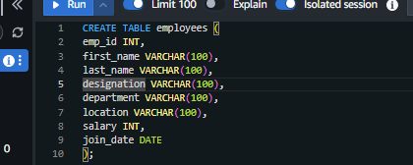

Upload CSV to S3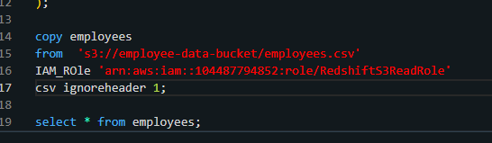

Load data into Redshift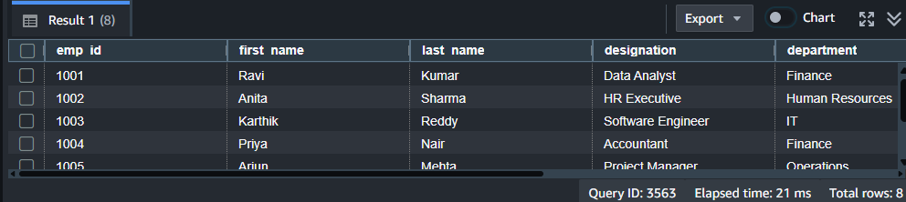

PHASE 2 — Secure Access & Data Retrieval
Store credentials in Secrets Manager
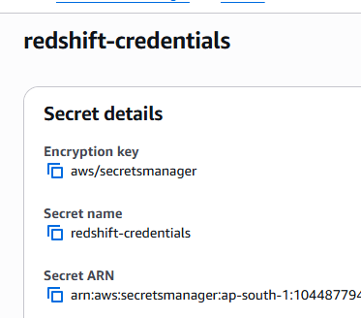

IAM Permissions Required
Attach to execution role:
- SecretsManagerReadWrite
- CloudWatchLogsFullAccess

Python Script Retrieves Data
- fetch credentials securely
- connect to Redshift
- load into pandas DataFrame

Output: Data loaded into pandas DataFrame for processing.
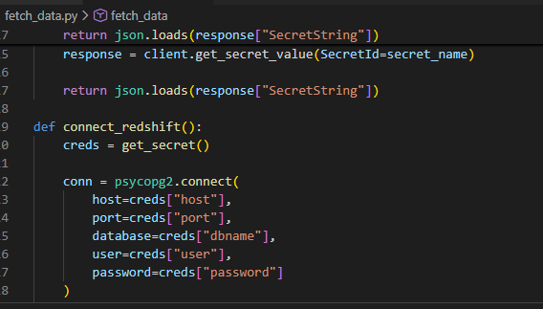
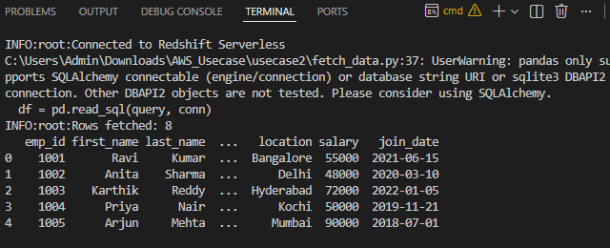

PHASE 3 — Multithreaded Data Processing
Improve performance by processing data concurrently.

Split dataset into chunks: Divide rows evenly across threads.
Process chunks in parallel: Each thread processes a chunk.
Transform & enrich data
Transformations applied:
✔ standardize names
✔ normalize location
✔ validate salary
✔ create salary_band column

Output: Processed Data Frame with enriched fields.

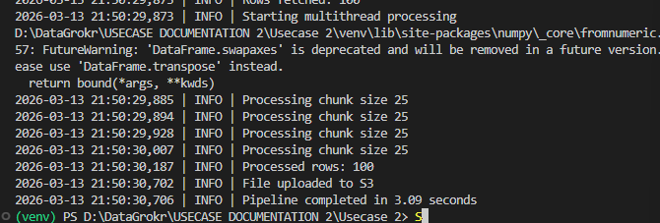
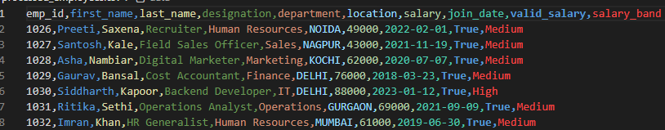

PHASE 5 — Containerization & Amazon ECR

Package the pipeline into a container for cloud execution.
- Docker
- Amazon ECR

Create Dockerfile
Build Docker image
Create ECR repository
Push image to ECR
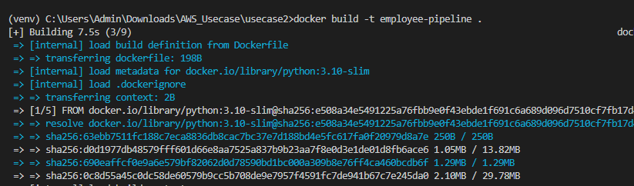
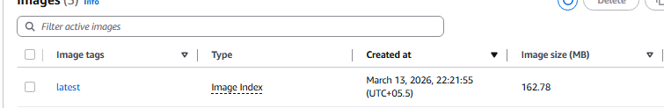

PHASE 6 — AWS Batch Serverless Execution
Run the container using serverless compute.

Services Used
- AWS Batch
- AWS Fargate
- CloudWatch Logs

Create IAM Role
BatchExecutionRole with:
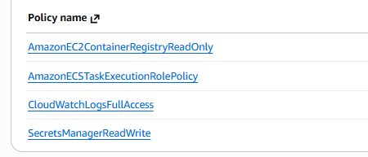

Create Job Queue, Job Definition
Links jobs to compute environment.

Submit Job
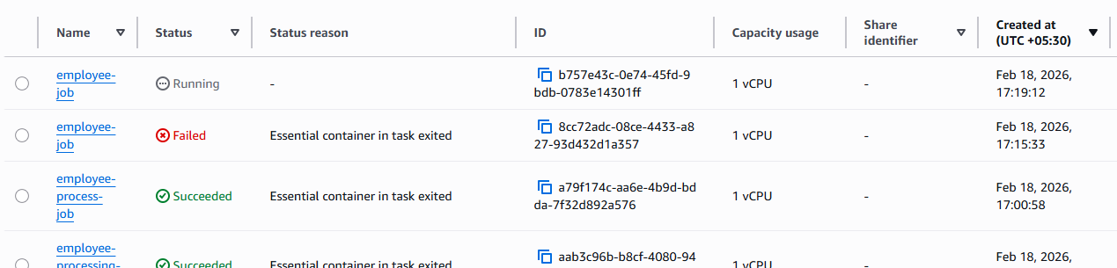

Monitoring
- Job status tracked in AWS Batch
- Logs available in CloudWatch

✅ Output
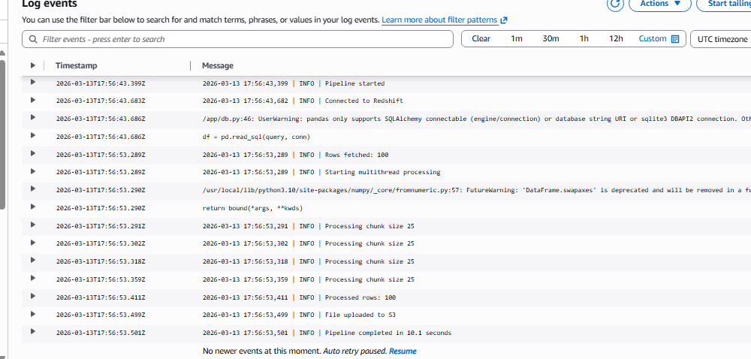

PHASE 7 — Persist Output to Amazon S3
AWS Batch storage is temporary. & S3 ensures durable storage

